|  |
| --- |
| **NAMA : ADITYA FAHMI SAPUTRA** |
| **NIM : 1207070004** |
| **KELAS : PCD TT** |
| **TUGAS KE-5** |

1. Percobaan operasi dasar

* 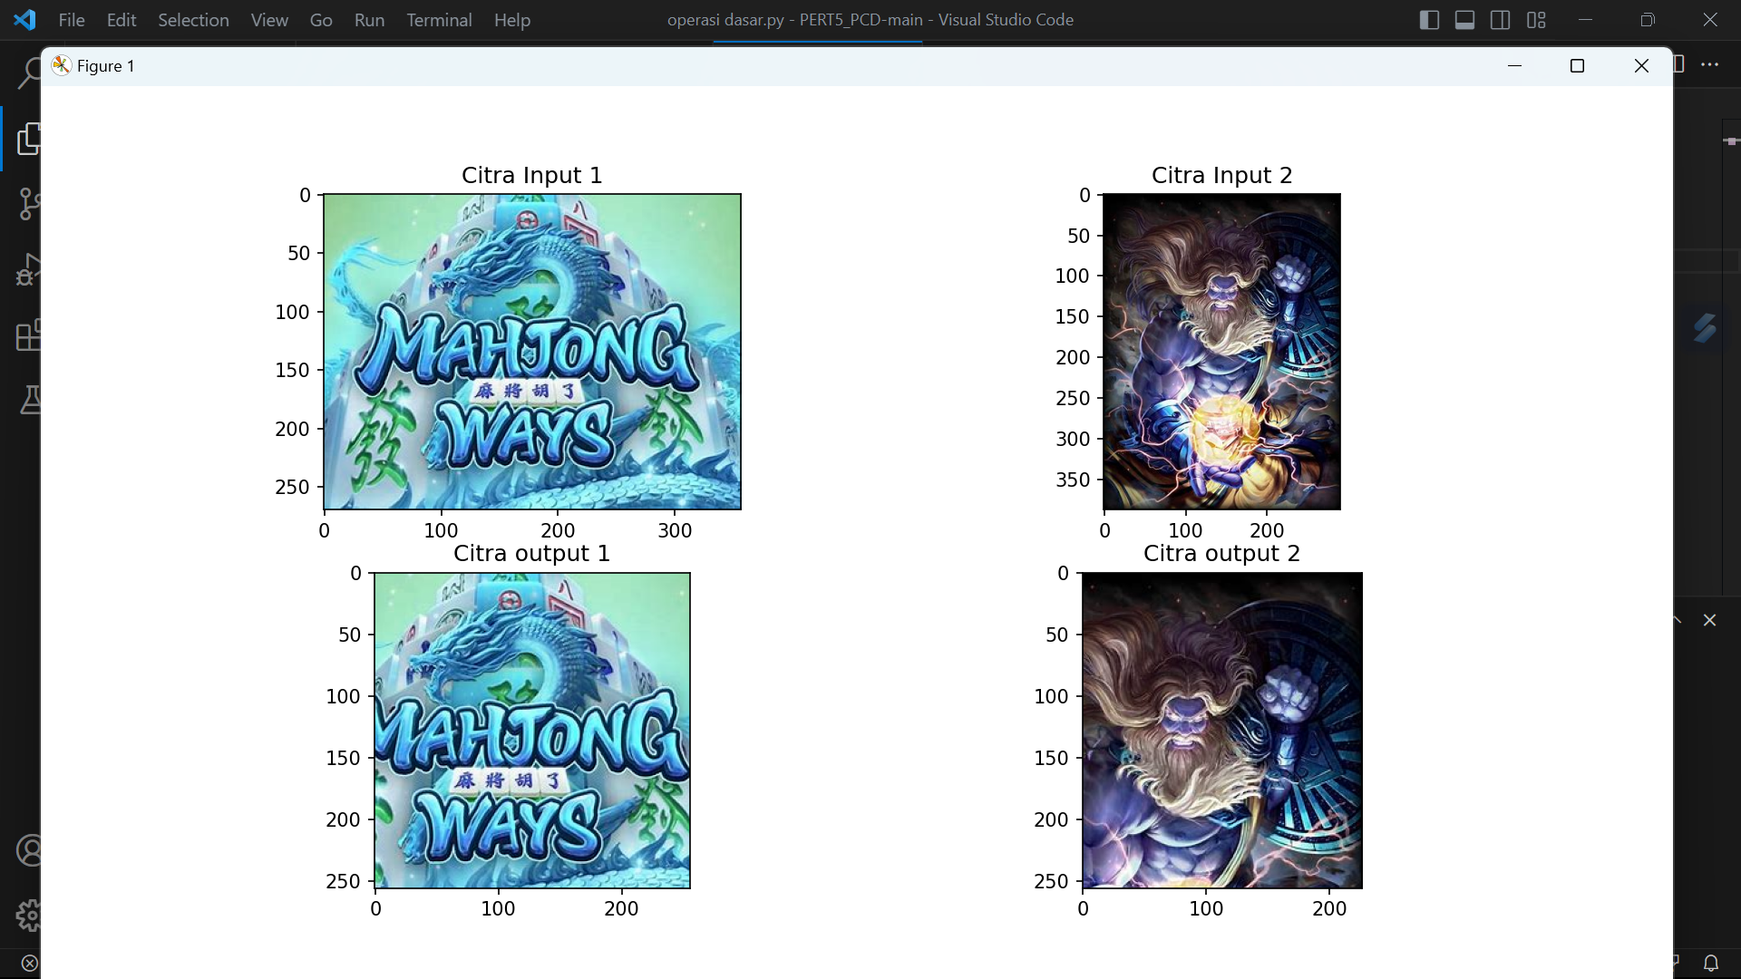
* 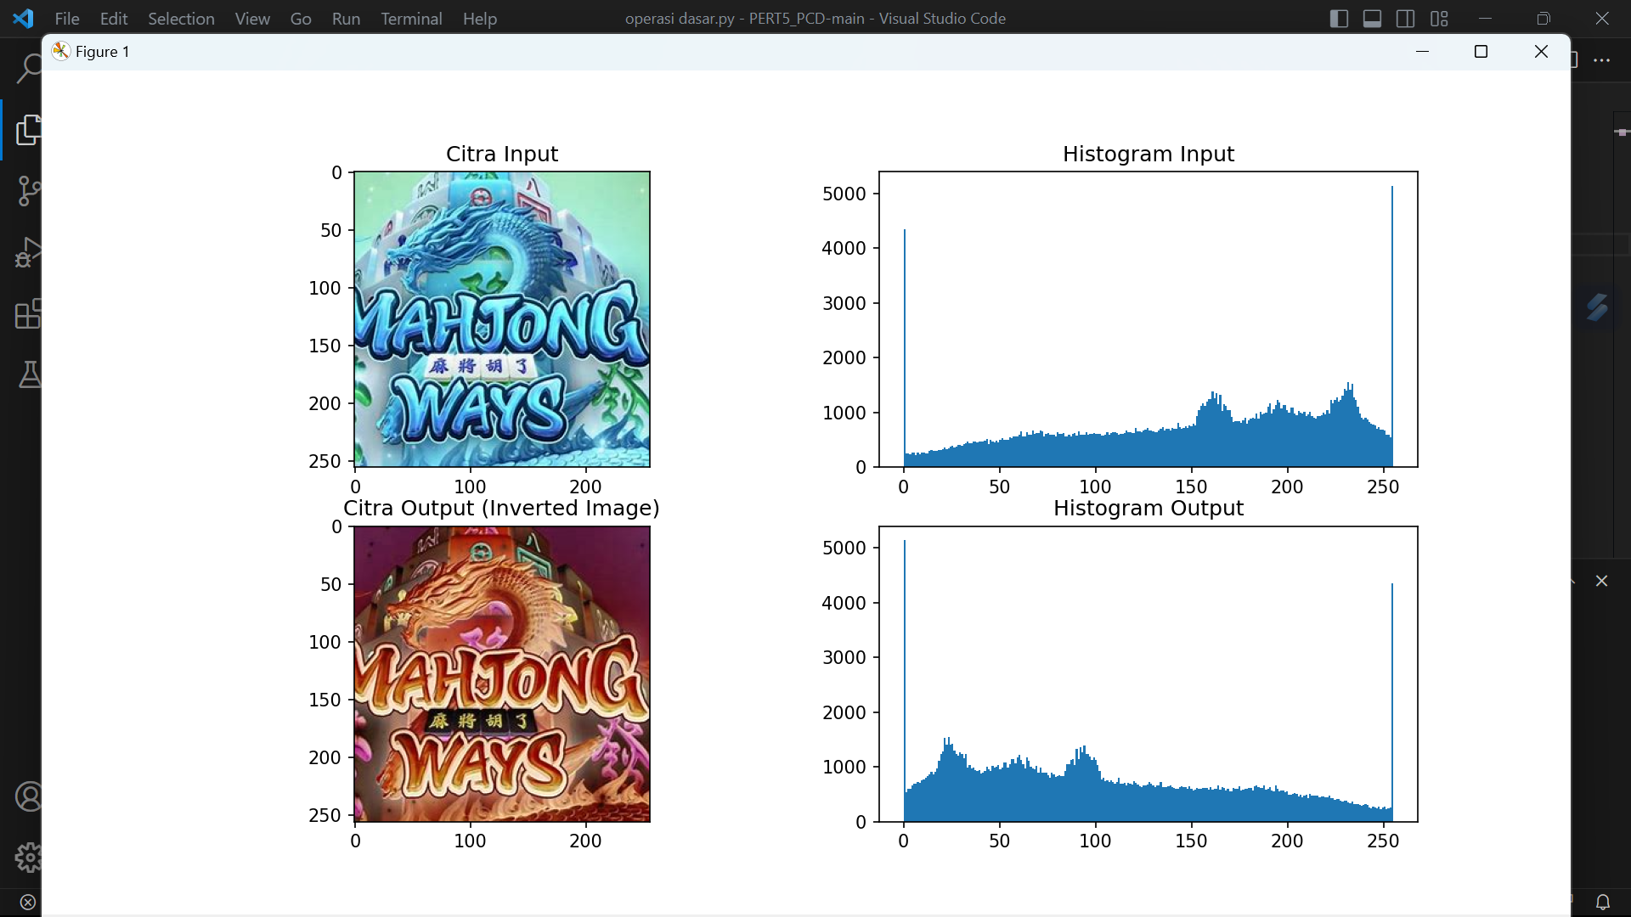
* 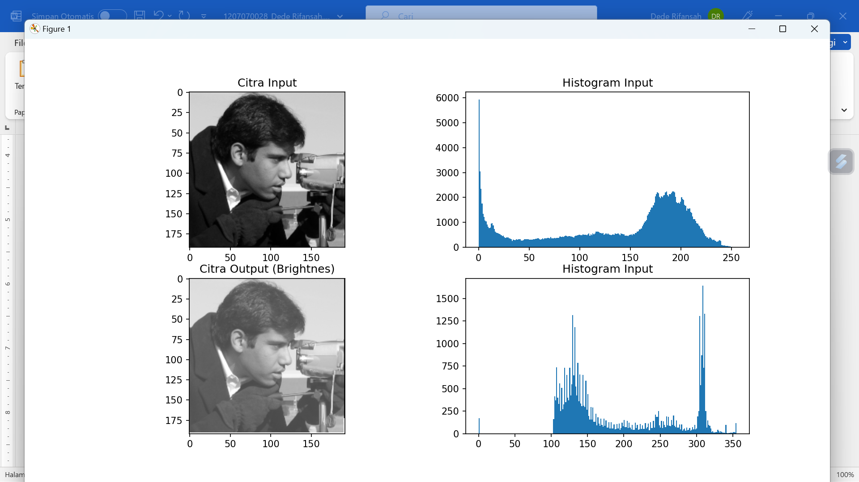

1. Percobaan Brightness,Contrass,Autolevel contrass

* 
 